**Practical 3:**

**Aim: Perform following tasks as per given instruction**

**1. Apply Data Cleaning methods on a given data set using Weka.**

**2. To perform data cleaning by handling missing values. Pre-processing for the missing value, by replacing them with all the following for the given dataset**

**\* With the global constant like Unknown or –infinity**

**\* Use the central tendency of attribute Mean (numerical attributes)**

**\* Use the class wise attribute Mean or median**

**\* Apply all three normalization methods to any one numeric attribute.**

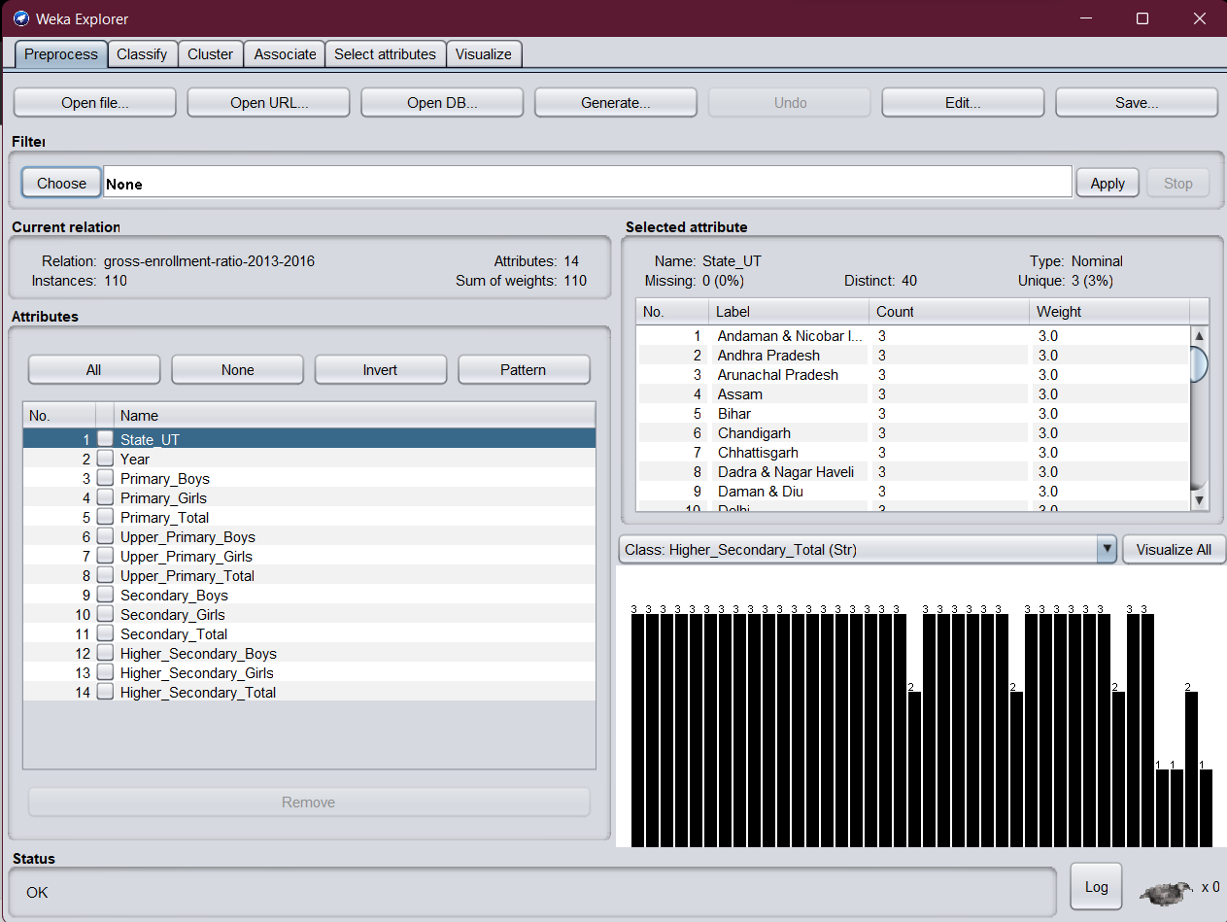

* Removing not needed attributes

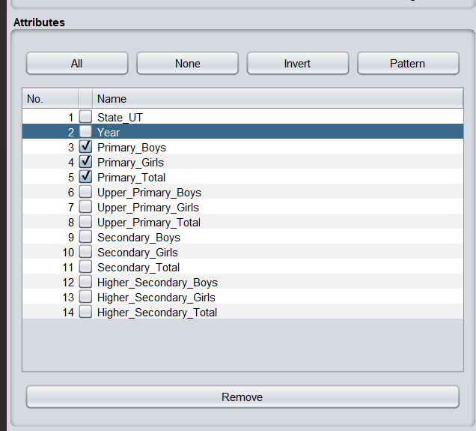



* Visualization of dataset after cleaning

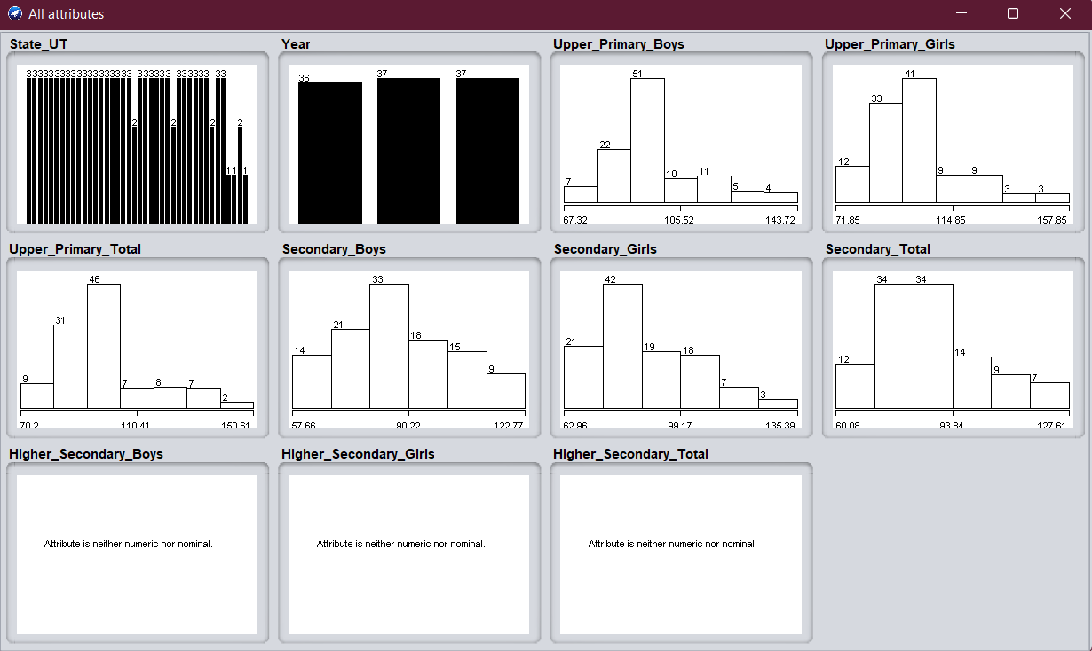

* Missing values in dataset

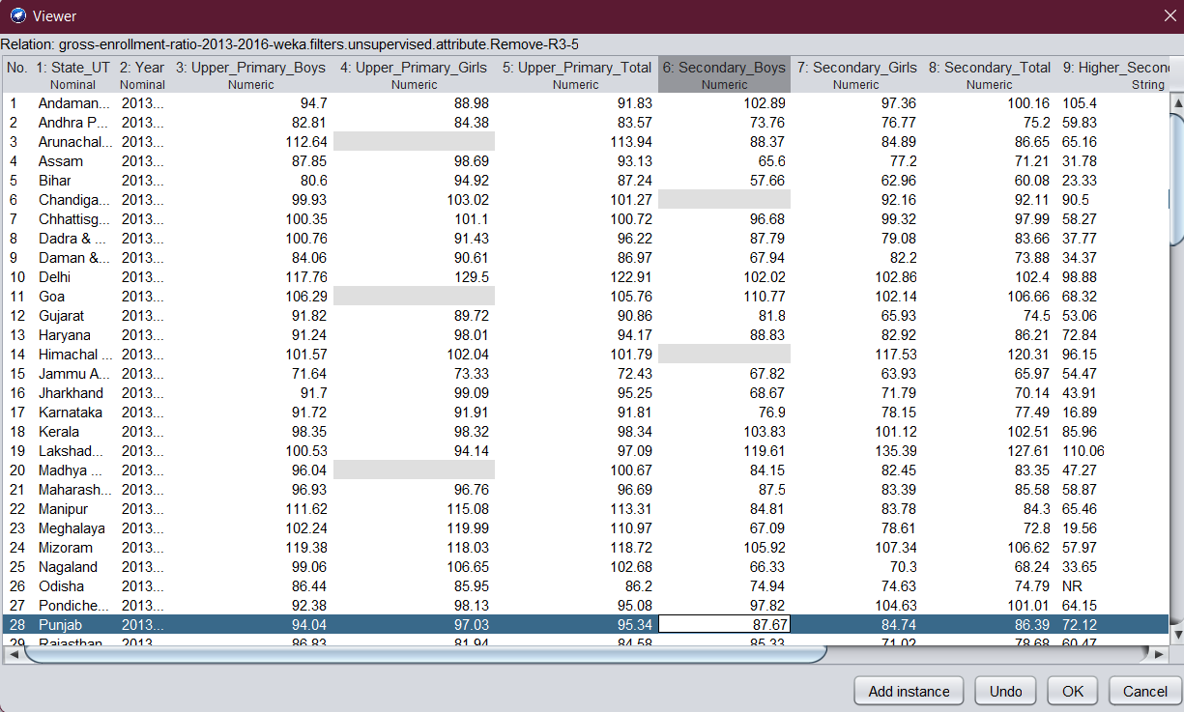

* Setting missing values without using any filter

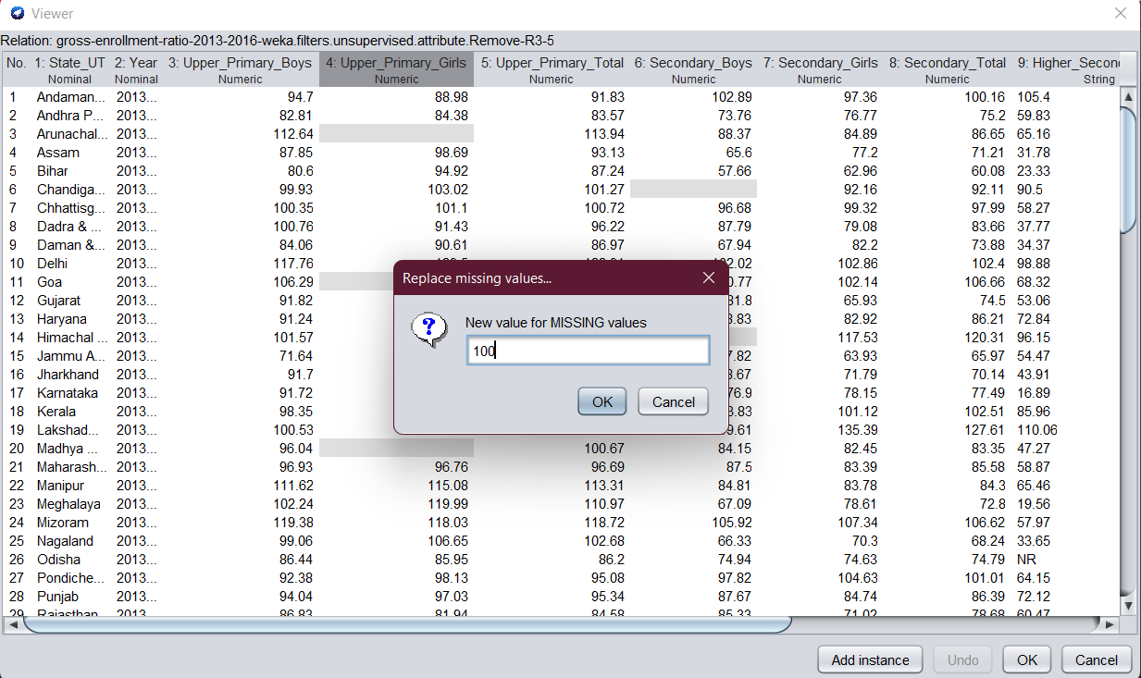

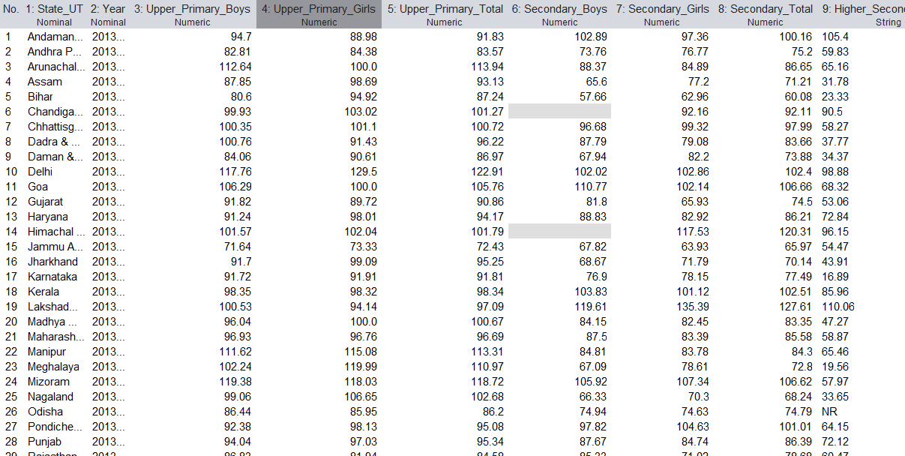



* Getting mean of the attribute

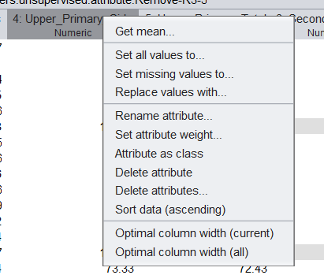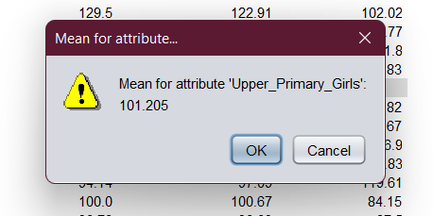

* Applying filter to replace missing values with constant

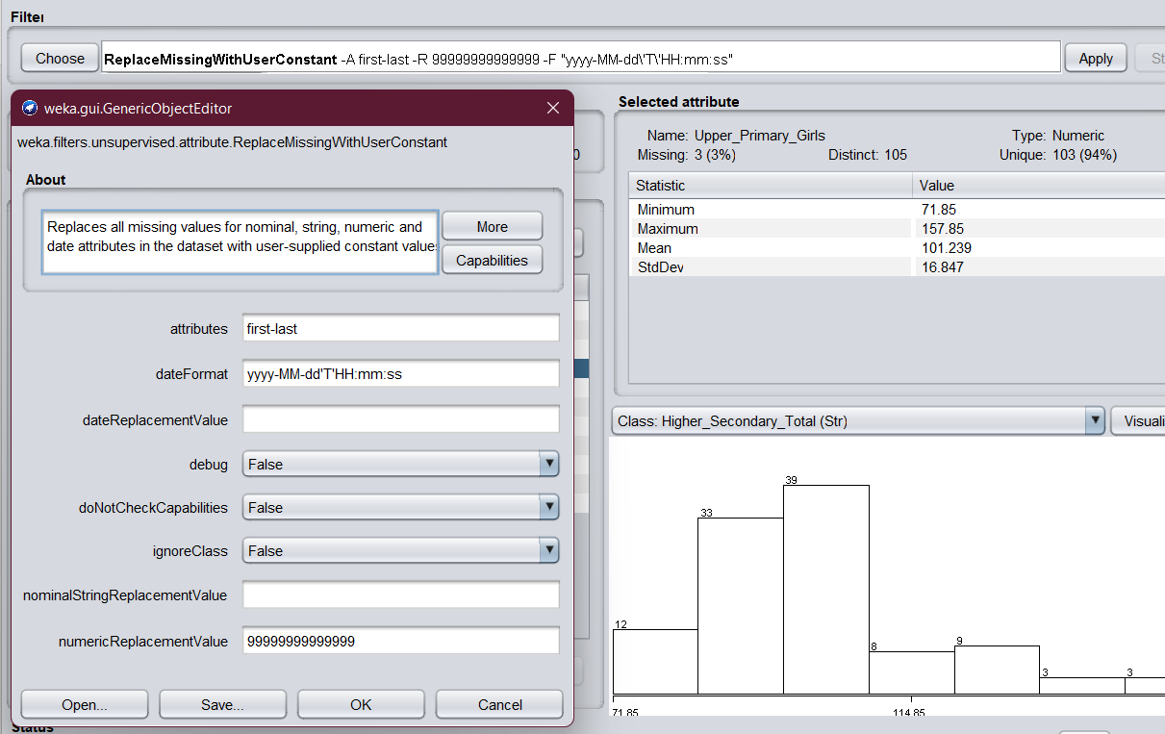

* Result after applying missing values with constant filter

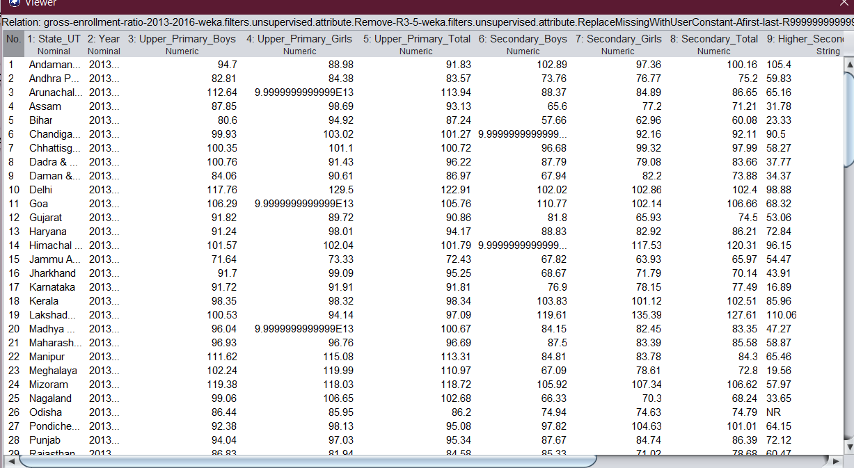



- After applying missing values filter (replacing with mean value)

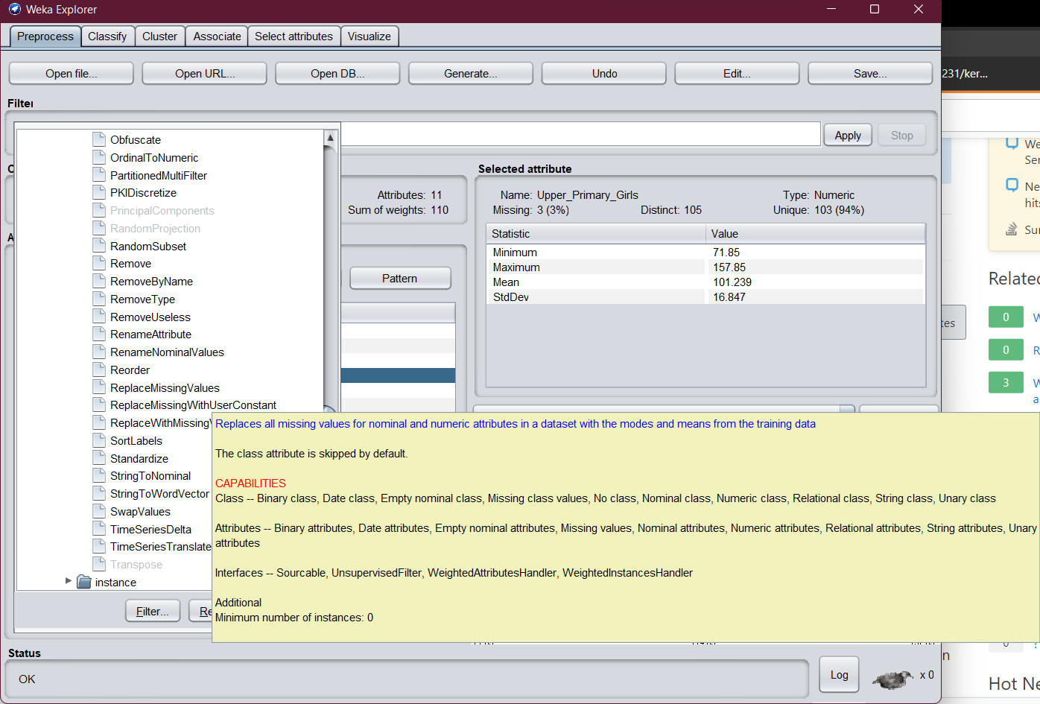



* Result after applying missing values filter

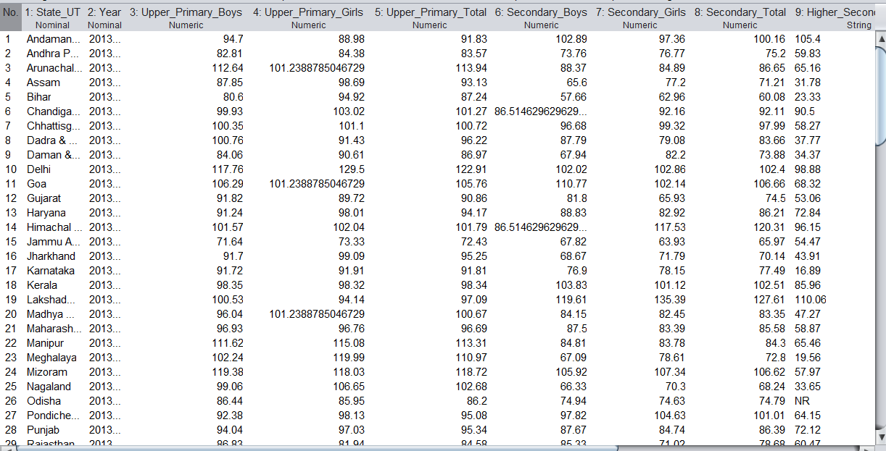



**Normalization of dataset**

* **Before**

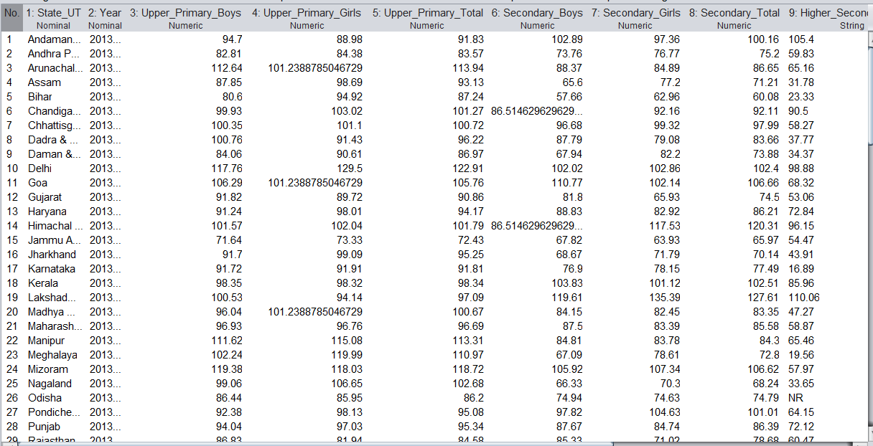

* **After Normalization**

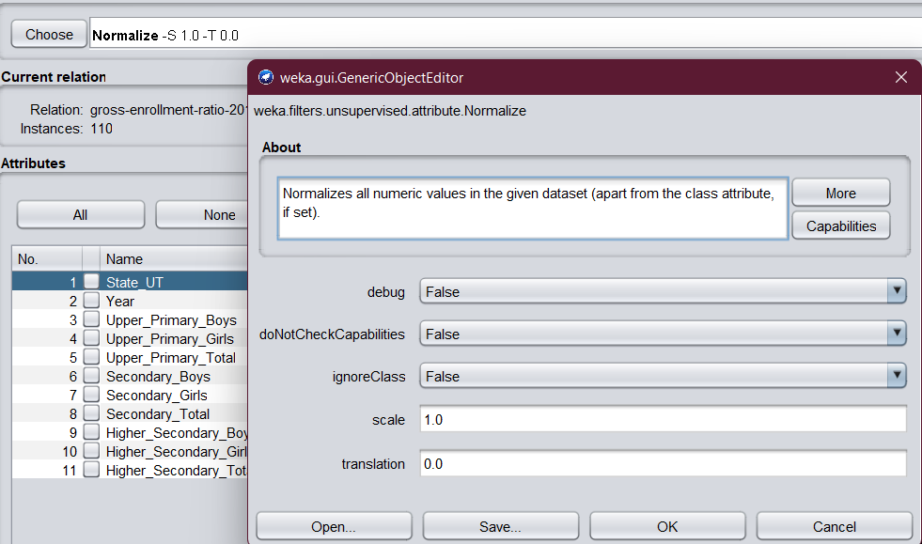

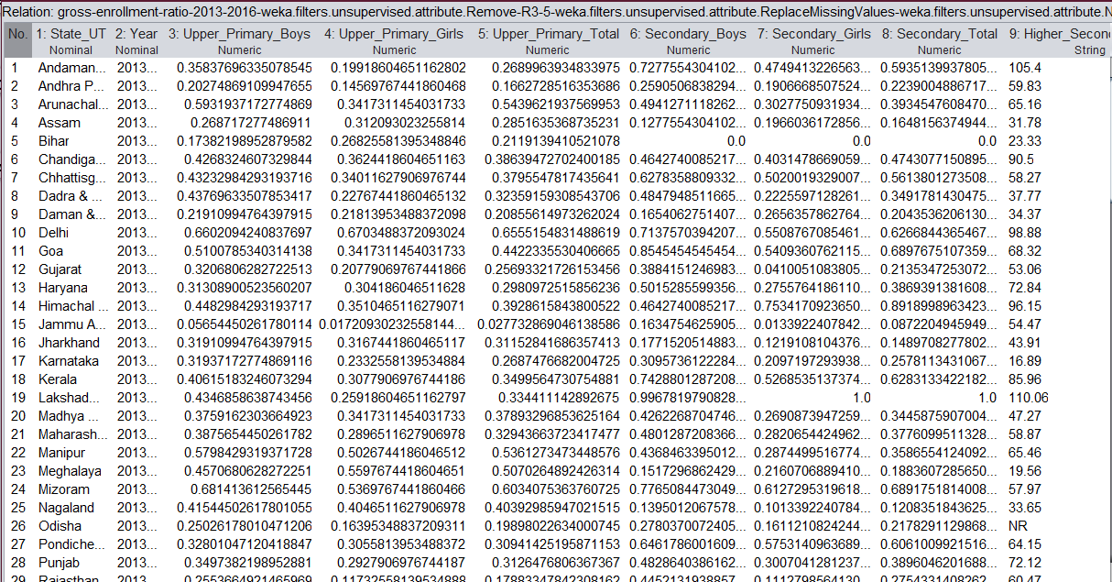

**Standardization**

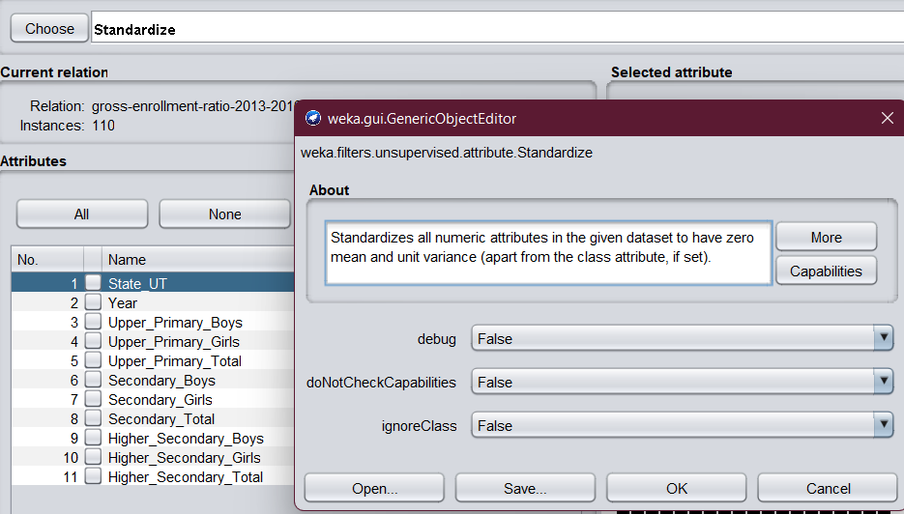

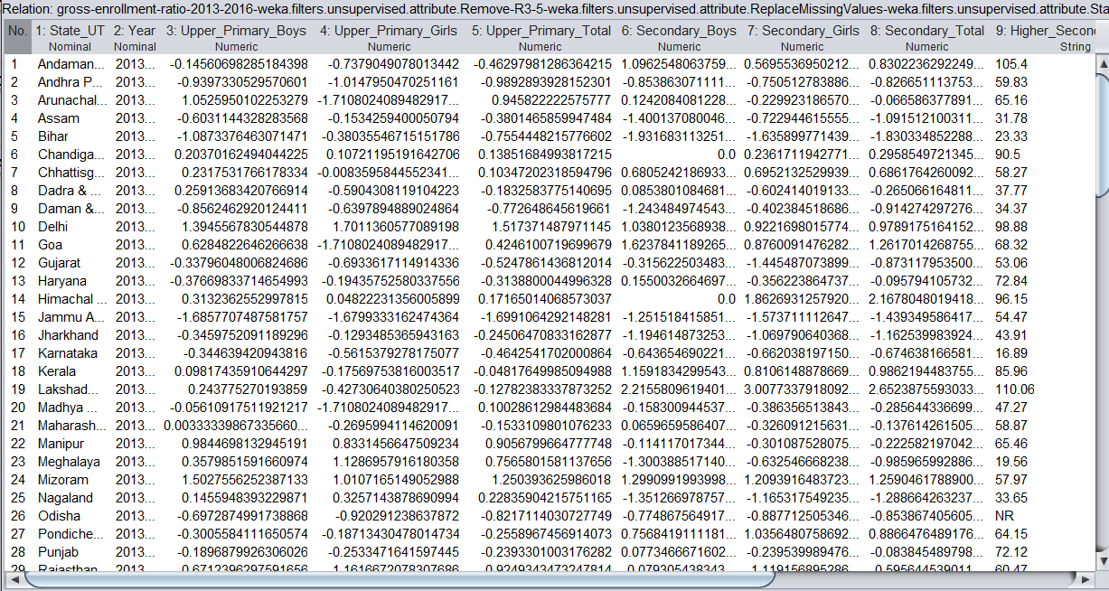

**Math Expression**

